**Assignment 7**

**Problem Statement:**

Working for an organization, you are required to provide them a safe and secure environment for the deployment of their resources. They might require different types of connectivity. Implement the following to fulfil the requirements of the company.

**Tasks To Be Performed:**

1. Create a VPC with 120.0.0.0/16 CIDR block.

2. Create 1 public subnet 2 private subnets and make sure you connect a NAT gateway for internet connectivity to a private subnet.

**Solution:**

Step 1:- Go to the VPC section & select VPC & more for creation of VPC with the given CIDR block & to create the necessary resources as mentioned attached to it.

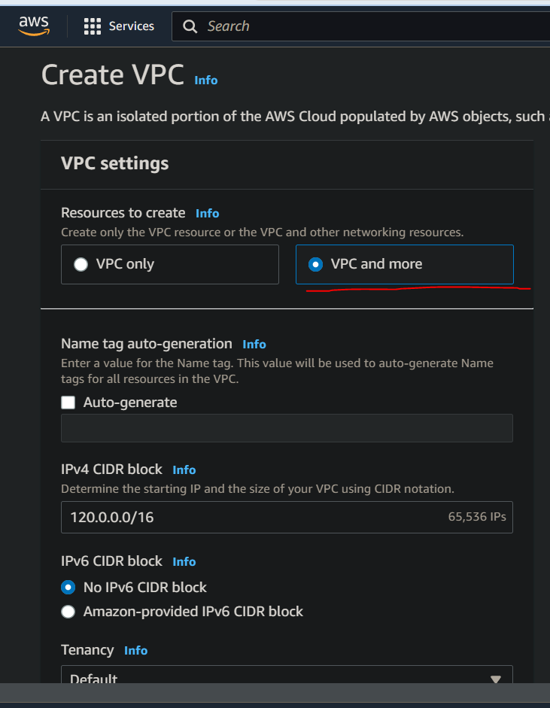

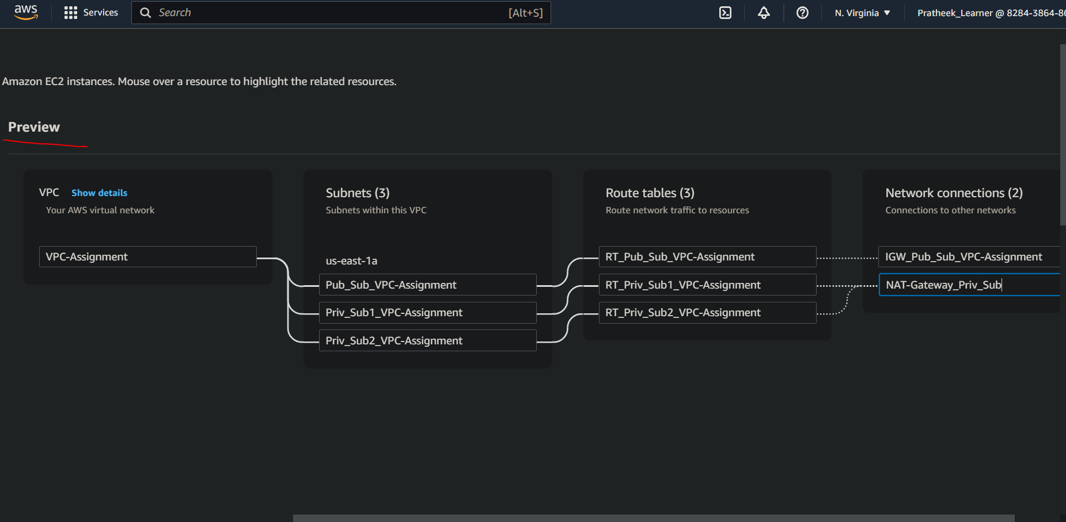

Step 2:- VPC creation & it’s associated resources as required are successfully created.

